SUNRISE HARVEST Mushroom Farm
Presents

Triple Mushroom Paella

By Melodie Porter
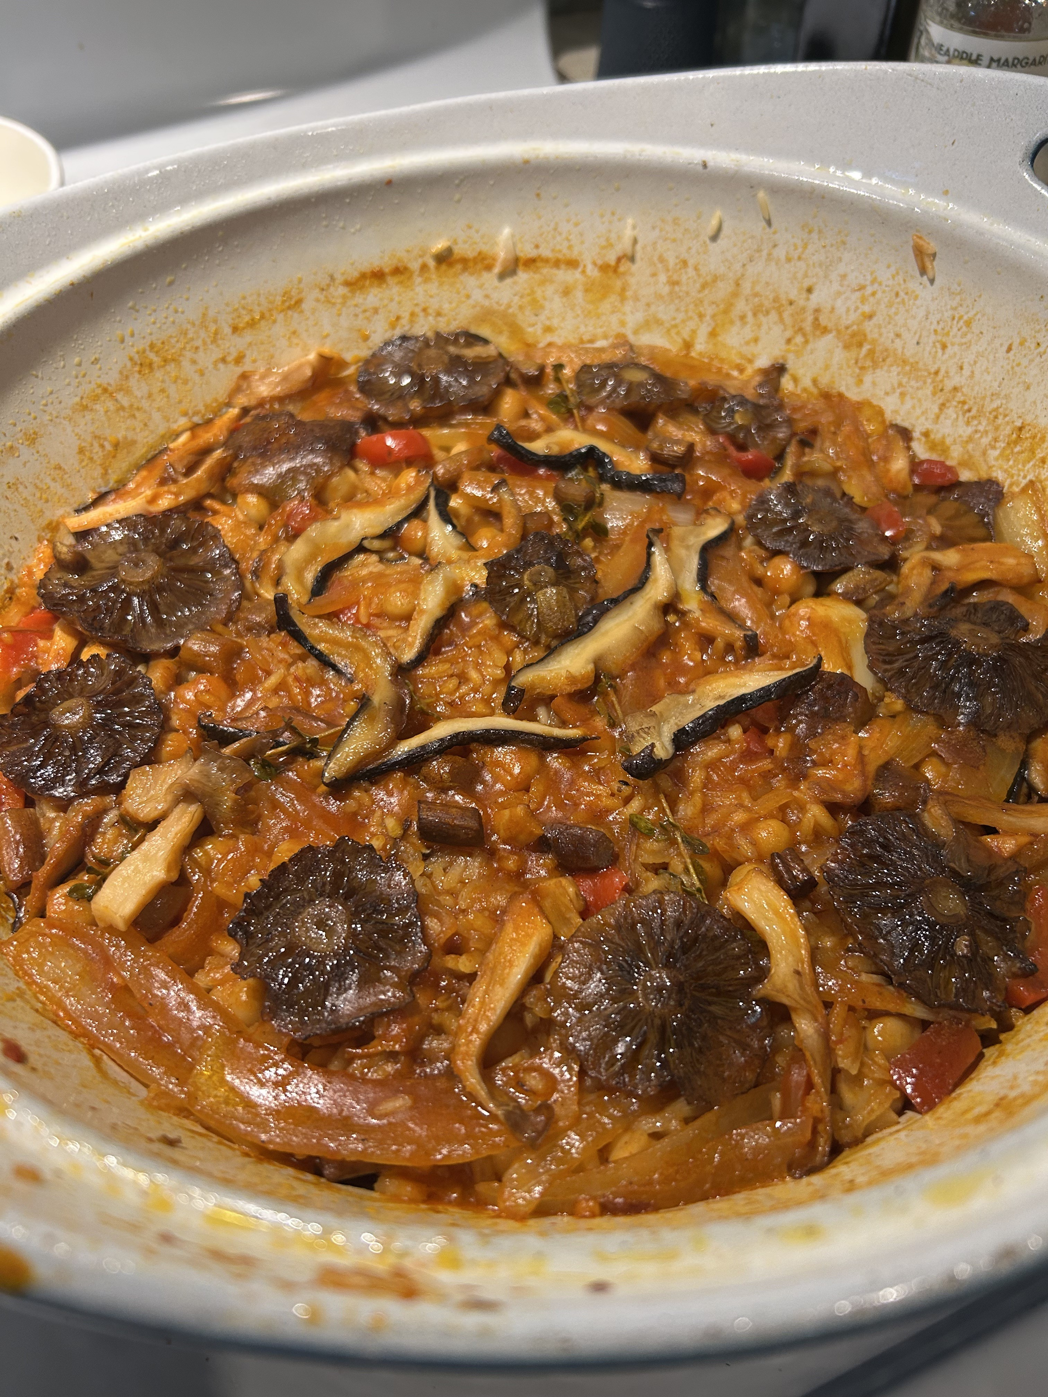

Ingredients  1 ½ lbs. Mushrooms  1 Medium onion  1 Bell pepper  4 cloves garlic  1 16oz Can of beans of choice  1/2c Crushed tomatoes with juice  1-1/2c Rice  3c Vegetable Broth  White wine vinegar for deglazing  Olive oil  Salt  2 tbsp Paprika  Pinch of Saffron  Fresh black pepper  to taste |  | 4-6  Yield | 15 minutes  Prep time | 1 hour  Total time

Directions
Slice or dice onions and pepper, smash cloves of garlic with skin removed and stir fry for 5 minutes on medium high heat. Set aside the onion mixture. Slice various mushrooms and stir fry in oil for 8 minutes each starting with the firmest mushroom and proceeding with the other mushrooms one at a time, salt and pepper to taste as you cook each. Don’t overcrowd the pan or the mushrooms won't get any browning. Combine the onion and pepper mixture back into the pan with all the sauteed mushrooms. Stir fry together for 2 minutes. Add drained beans, paprika, saffron and salt and pepper to taste. Stir fry together for 1-2 minutes. Deglaze with white wine vinegar and take all the brown bits off the pan. Add crushed tomatoes and cook down on medium heat so most of the juice is evaporated. Measure and add in your rice and stir fry together for a few minutes until the rice grains look more solid white, about 3-5 minutes. Measure your broth and add this into your mixture, making sure all the browned bits are scraped off and all the rice is below the surface. Bring mixture to boil then reduce heat to medium/low for 15-20 until the rice is cooked through.
Traditionally the lid is left off the pot all the way through the end of cooking time, which gives a different texture. I have done both ways, but you must watch your heat level to not evaporate the liquid before the rice is cooked through. If you think this is happening, put the lid on and lower the heat further. It’s going to be fine.

SUBSTITutions
Crushed tomatoes: tomato puree or diced tomatoes.
Paprika: Smoked paprika or HOT paprika
Saffron: ¼ tsp Turmeric powder

